**ARC-GIS**

**EXCERCISE: 5**



**QUERIES**

**Attribute data queries**

1. **A**: 3 records are selected

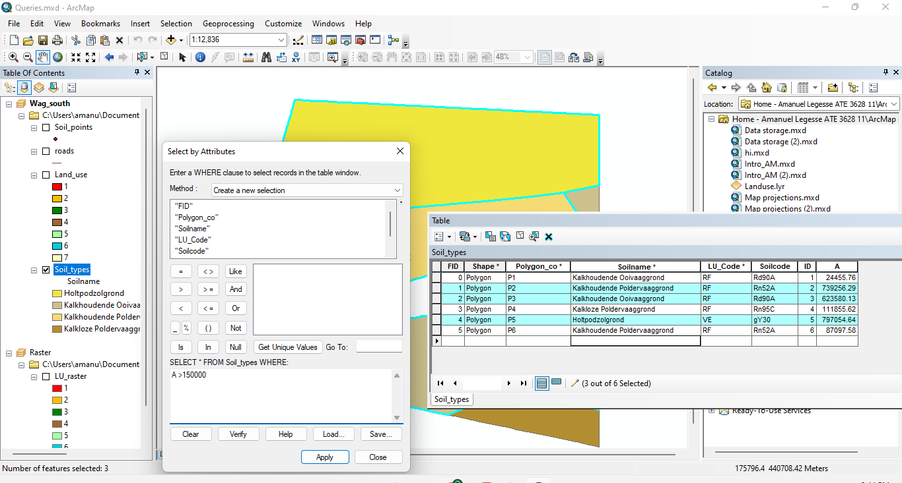

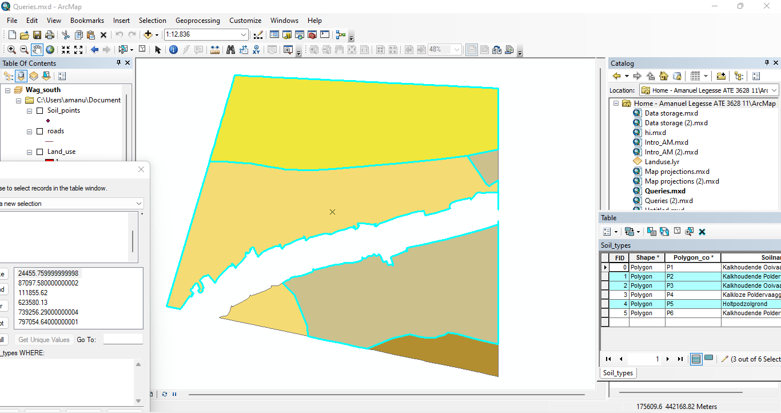

**B**: There is 1 kalkhoudende poldervaaggrond records selected

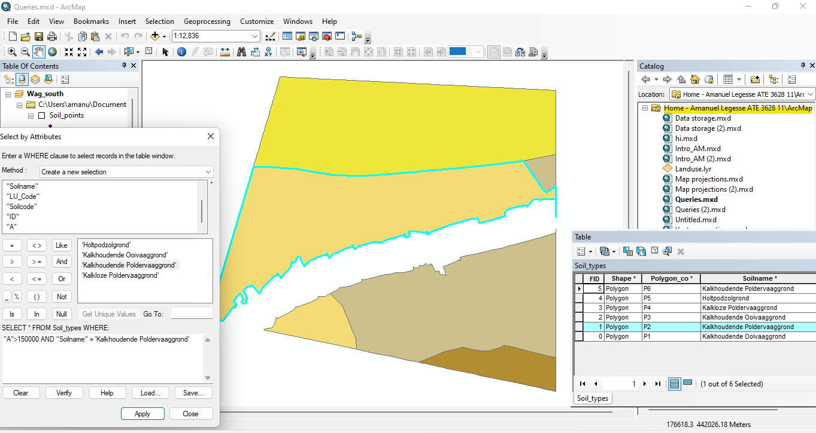

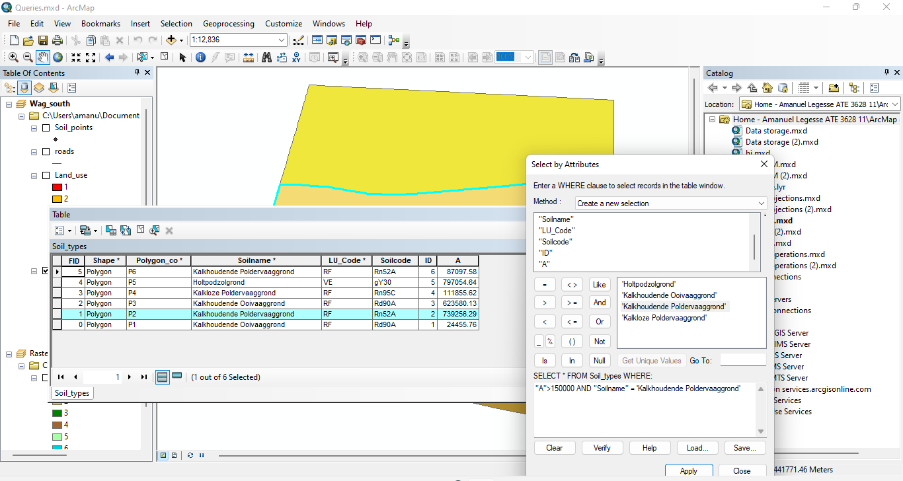

**C**: Yes the selection can be made at once using the Boolean expression AND.

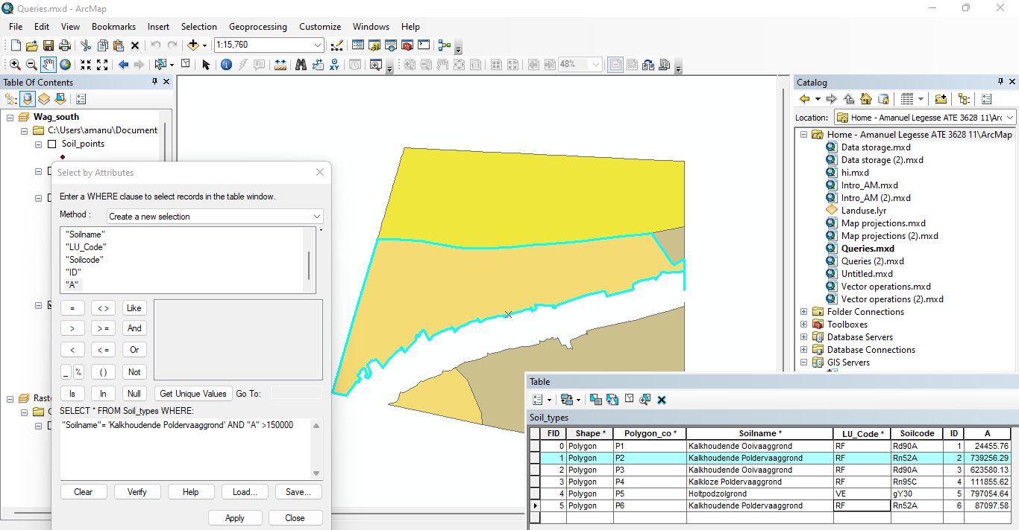

**D**: Select: "Soilname"

From: Soil_types

Where: "Soilname"= 'Kalkhoudende Poldervaaggrond'

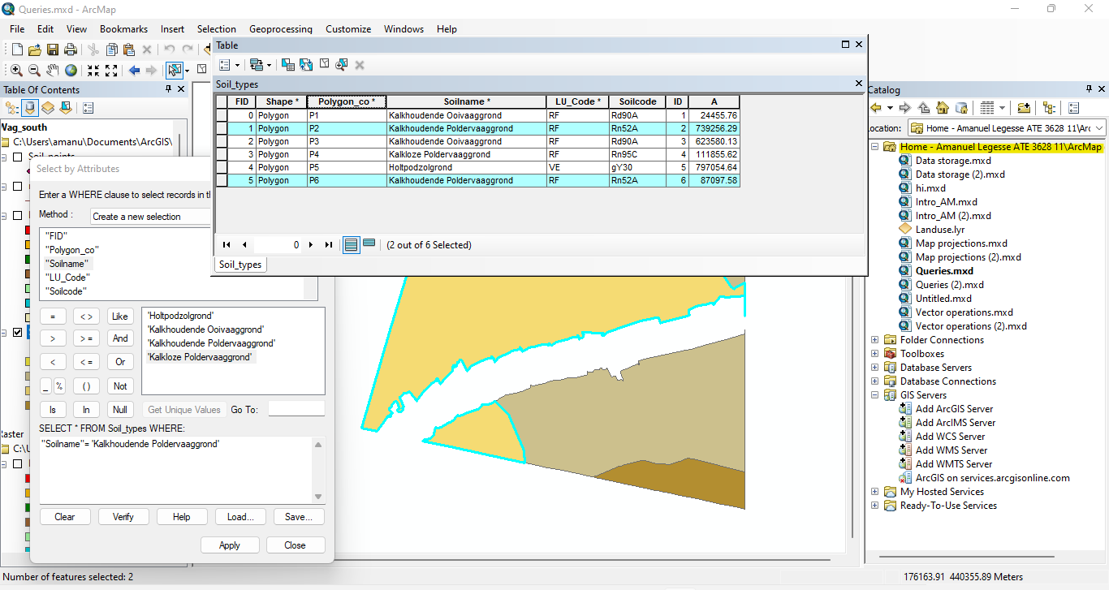

**E**: 3 records are selected after adding features with LU_code ‘VE’

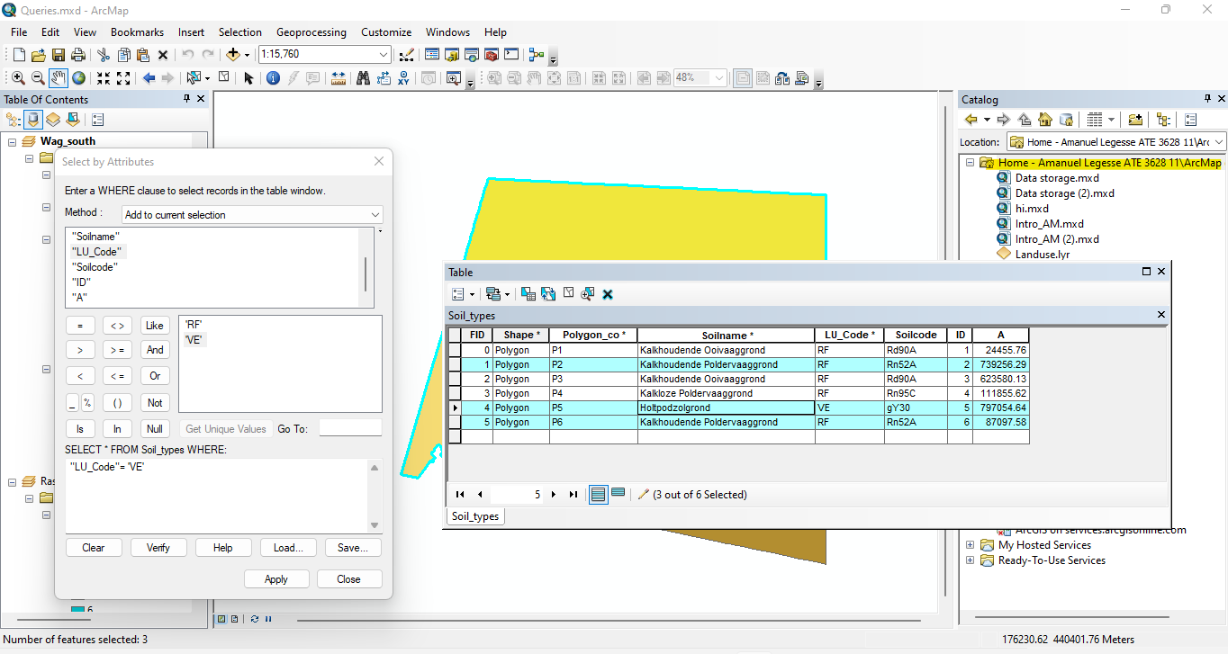

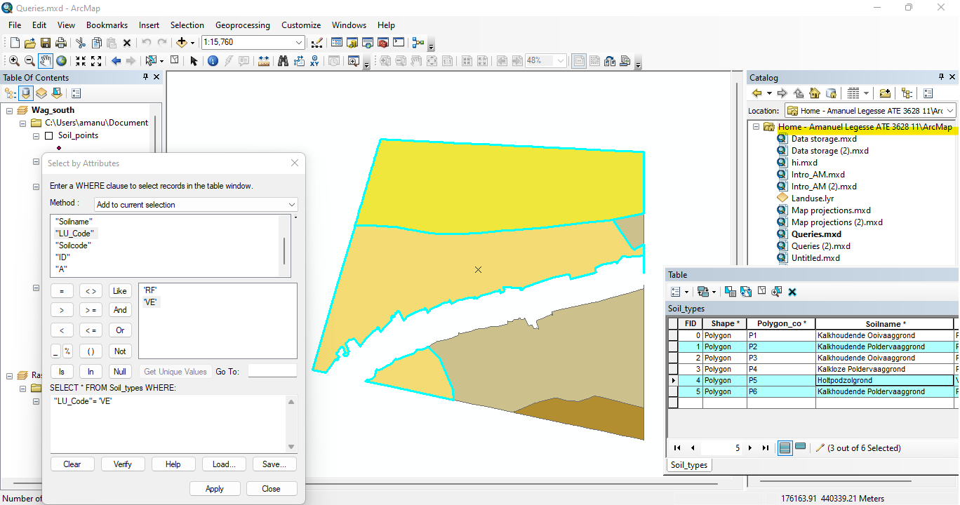

**F**: Yes the selection can be made at once using the Boolean expression OR.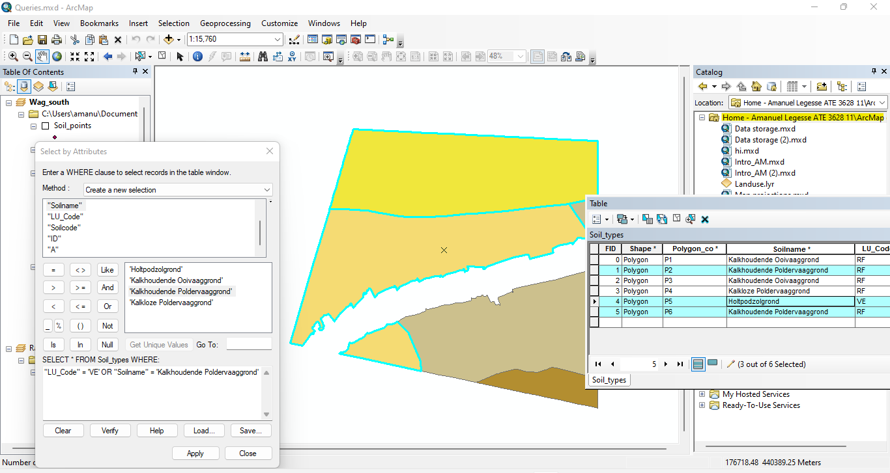

**Sorting attributes**

1. polygon_co is sorted in a descending order as seen below.

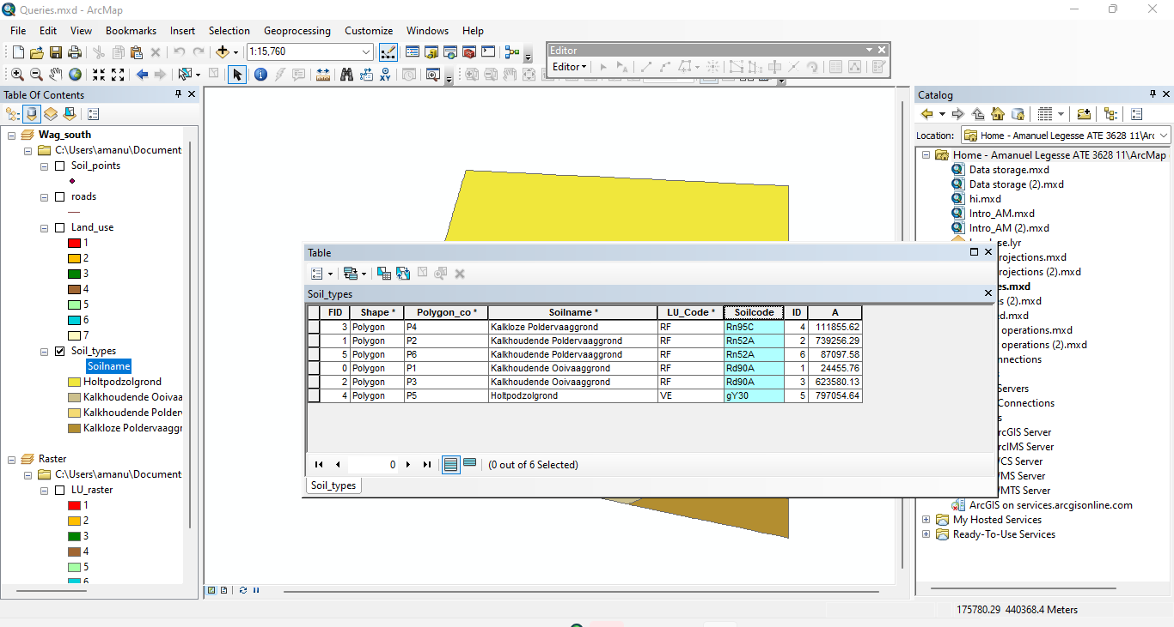

**Feature selection by cursor**

1. **A**: 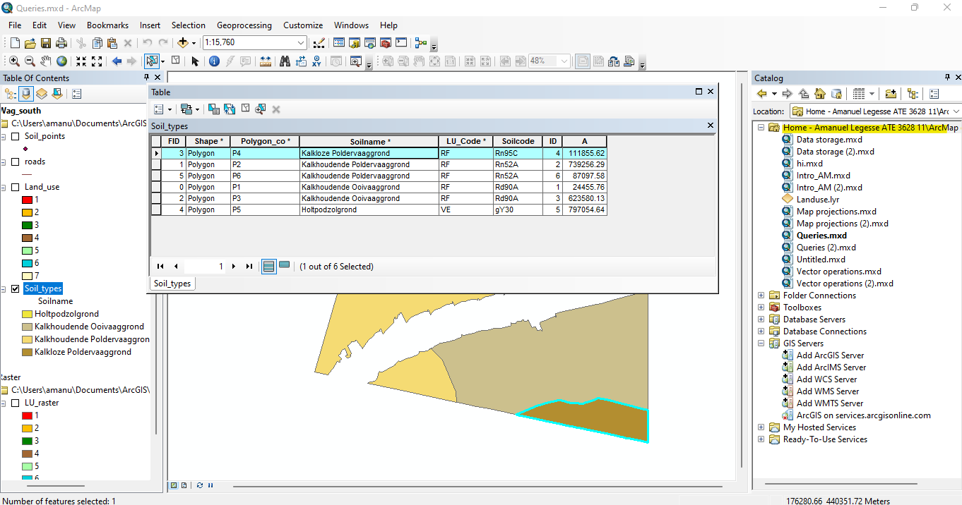

**B**: Select: "Soilname"

From: Soil_types

Where: "Soilname"= ' Kalkloze poldervaaggrond’

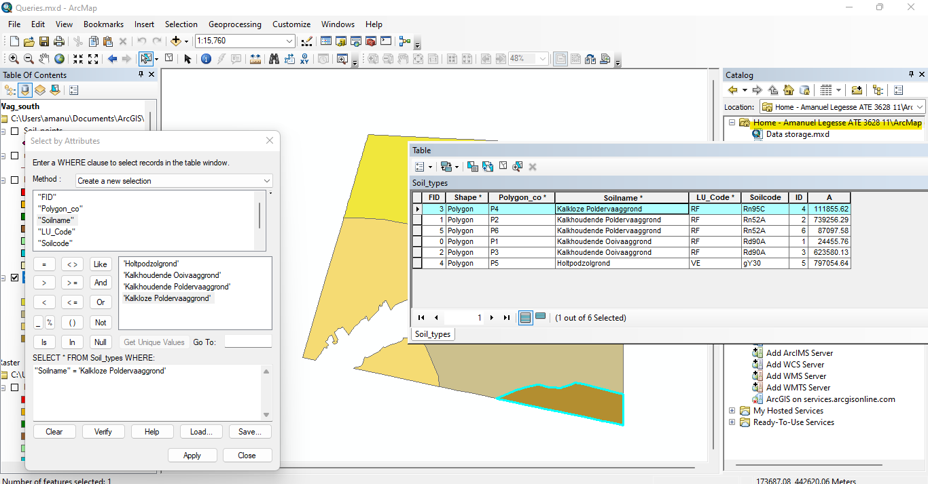

**C**. After removing the most southern soil feature which is 'Kalkloze Poldervaaggrond', the most northern one ('Holtpodzolgrond’) is selected.

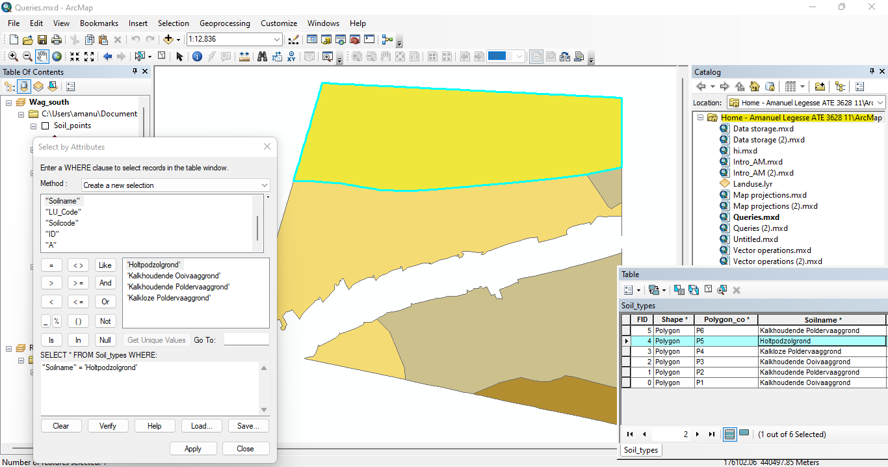

A: The selected feature which is the mathematics building is highlighted as yellow.

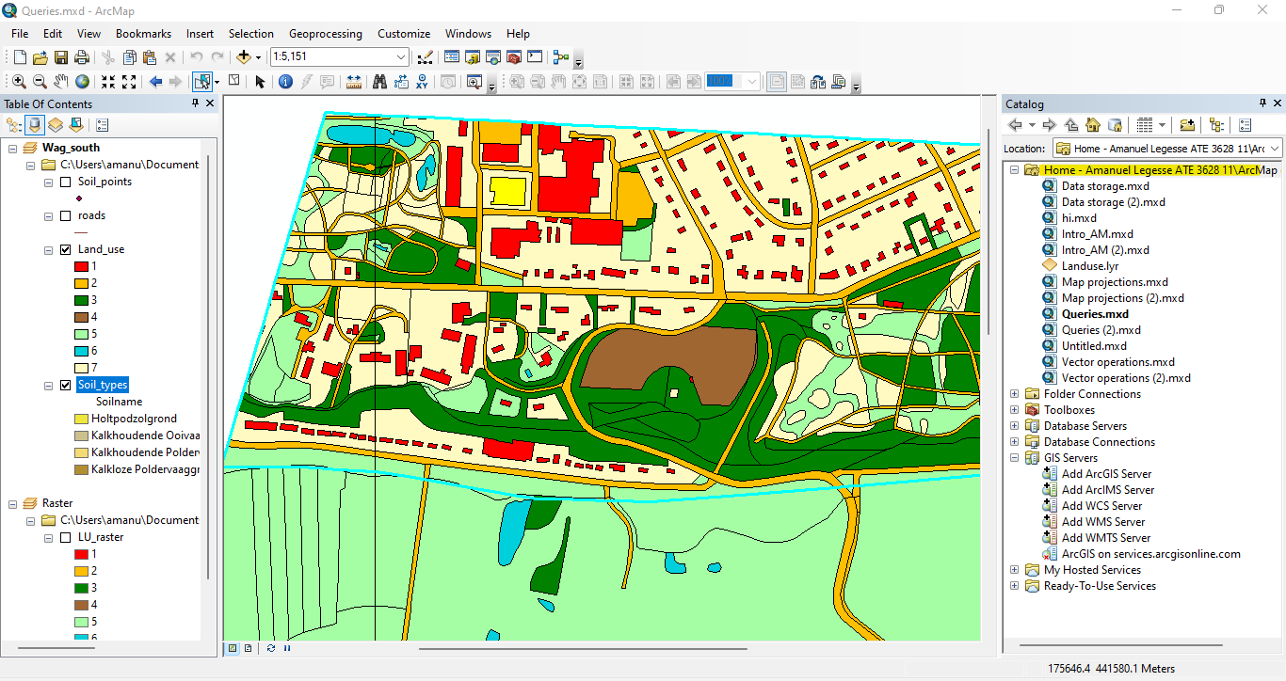

* The mathematics building also the soil feature in which the building is located is selected

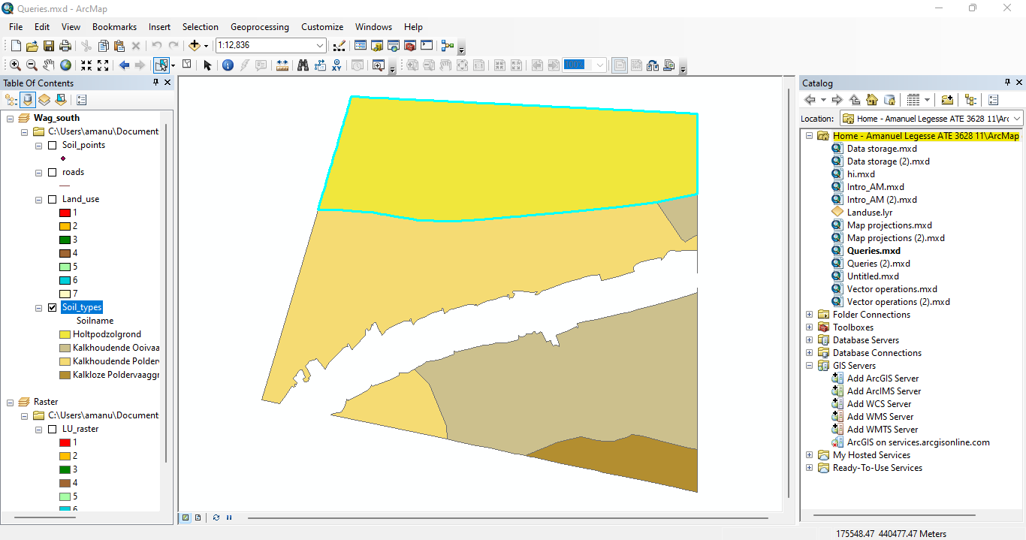

**B**:

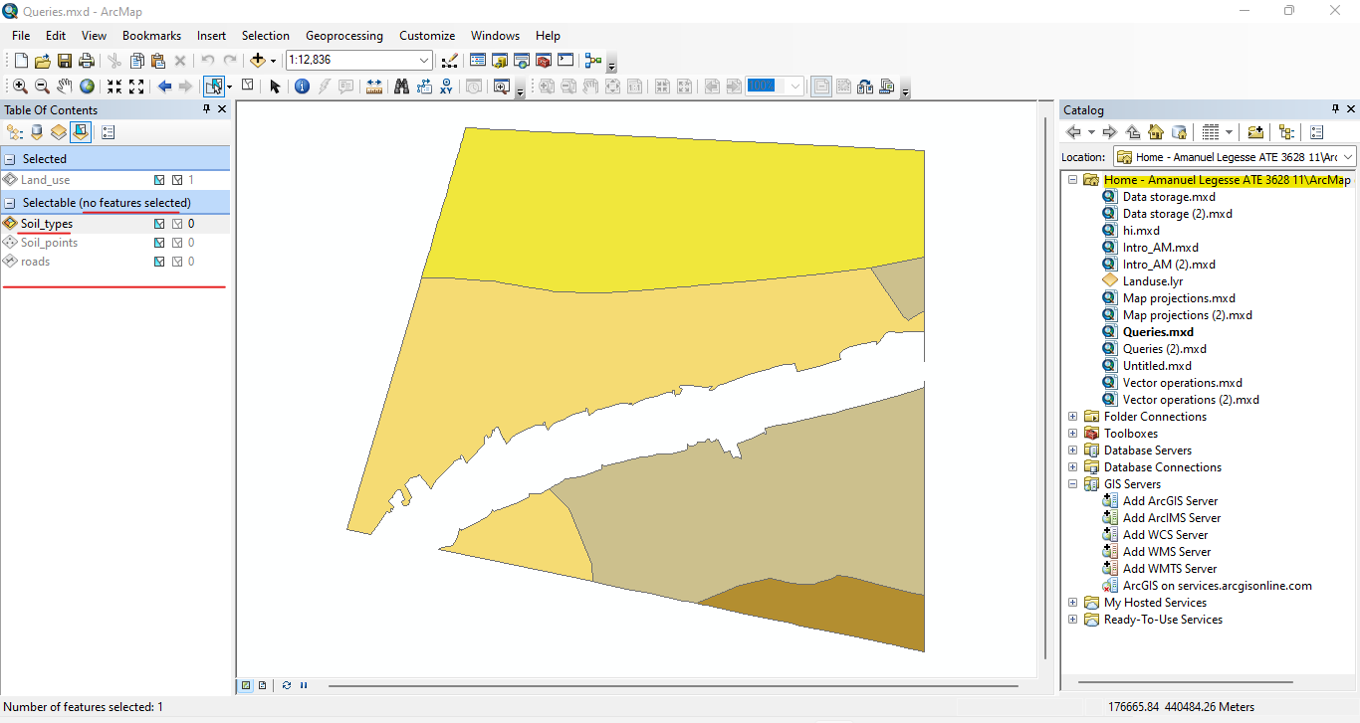

**C**: Now that the soil_types has been made not selectable the mathematics building is selected t and not the soil feature on which this building is located.

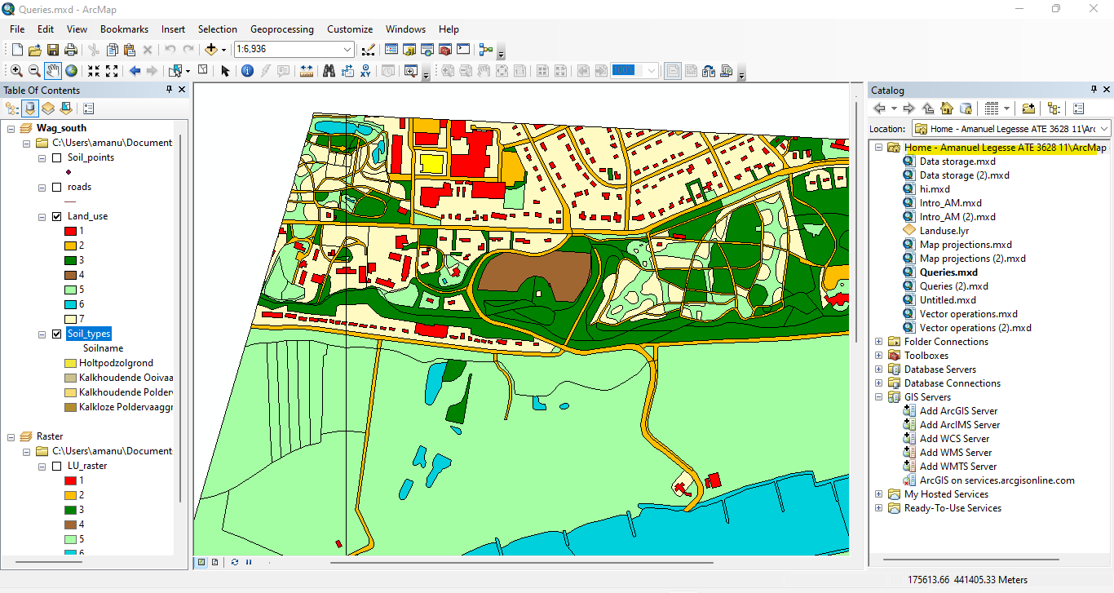

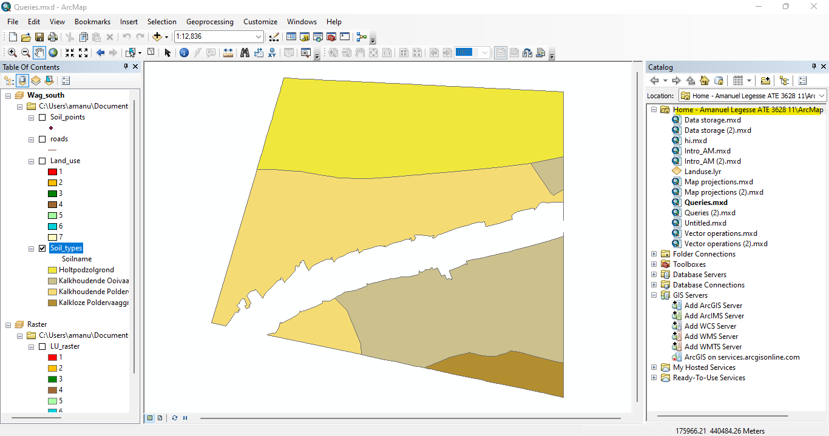

1. The soil codes of the selected features are Rd90A, Rn52A and gY30.

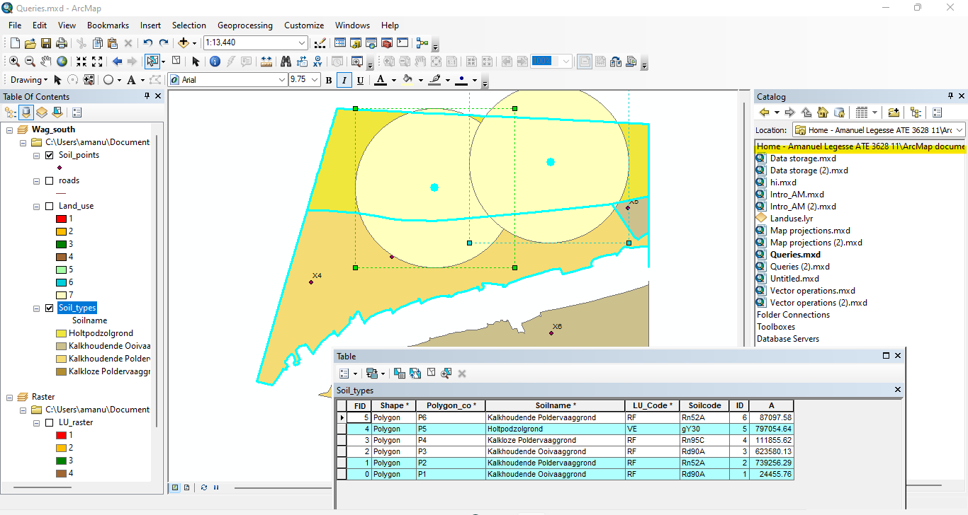

1. A: 2 features are selected, ‘kalkloze poldervaaggrond’ and ‘kalkhoudende ooivaaggrond’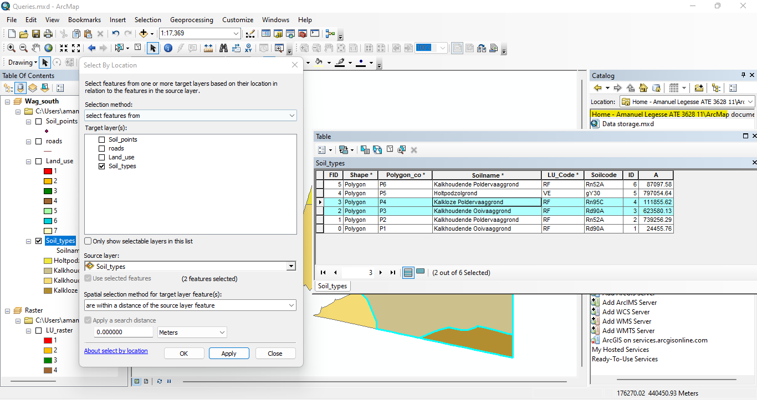

**B**: By using ‘touch the boundary of’ spatial relationship, there can be made the same selection.

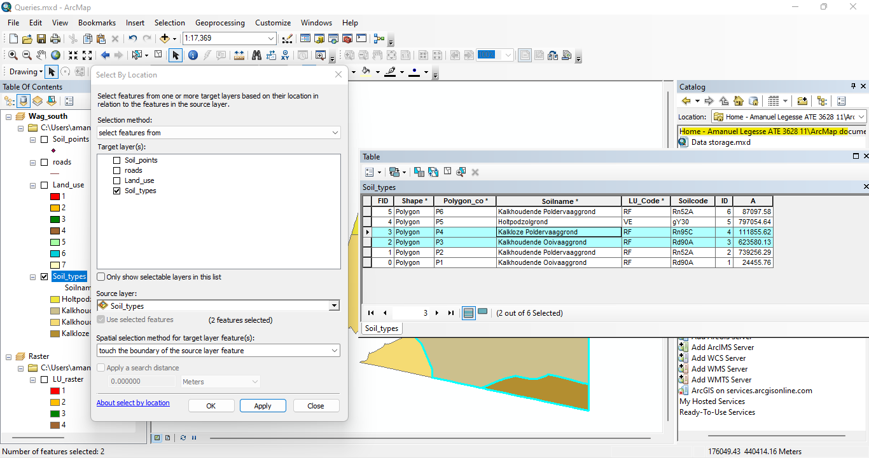

**C**: This selection results in 68 selected features in the land_use dataset. 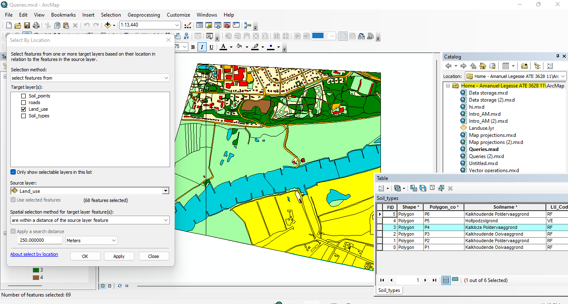

1. Point X5, X6, X7 are within the soil features classified as ‘Kalkhoudende Ooivaaggrond’.

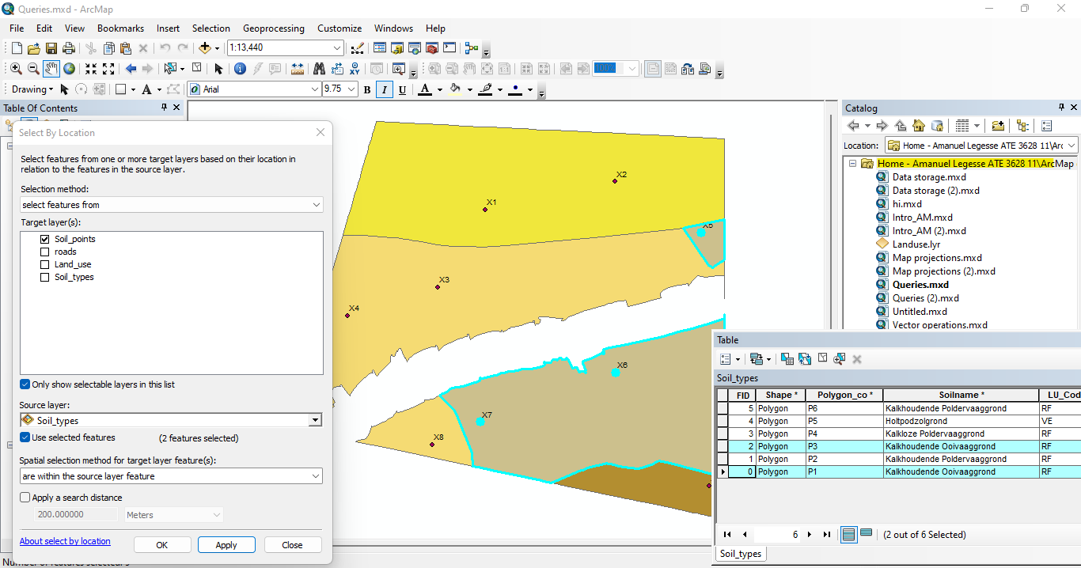

1. A: The nearest soil profile point to the Veerweg is point X1.

B: The distance is 147.3 meters.

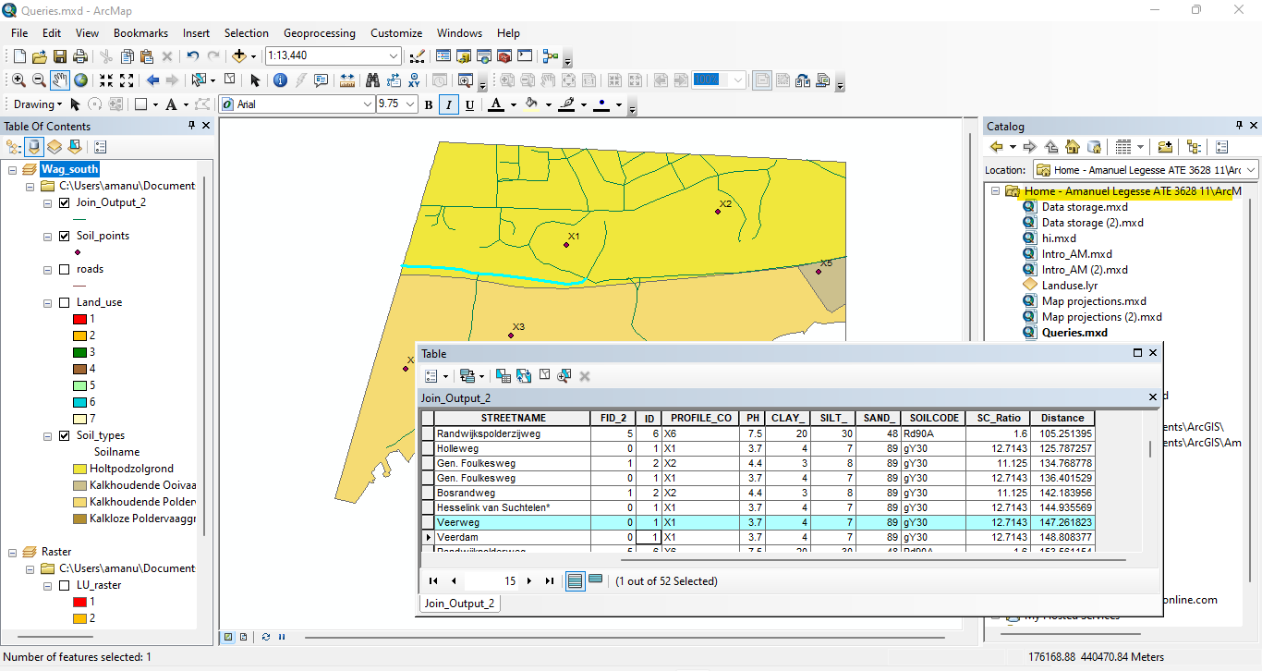

**Saving a selection into a new vector dataset**

1. **A:**

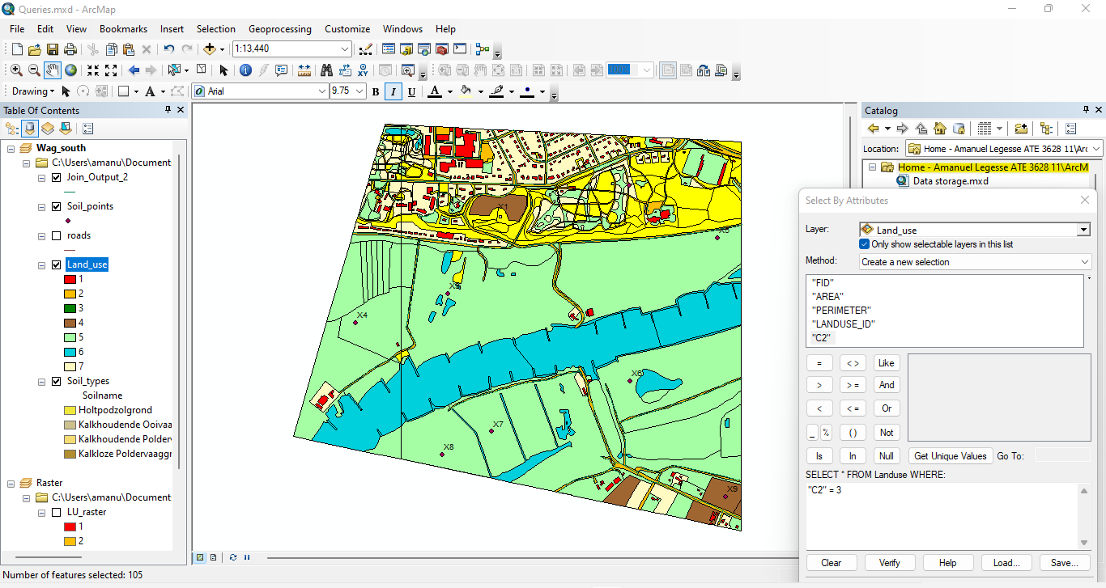

**B:**

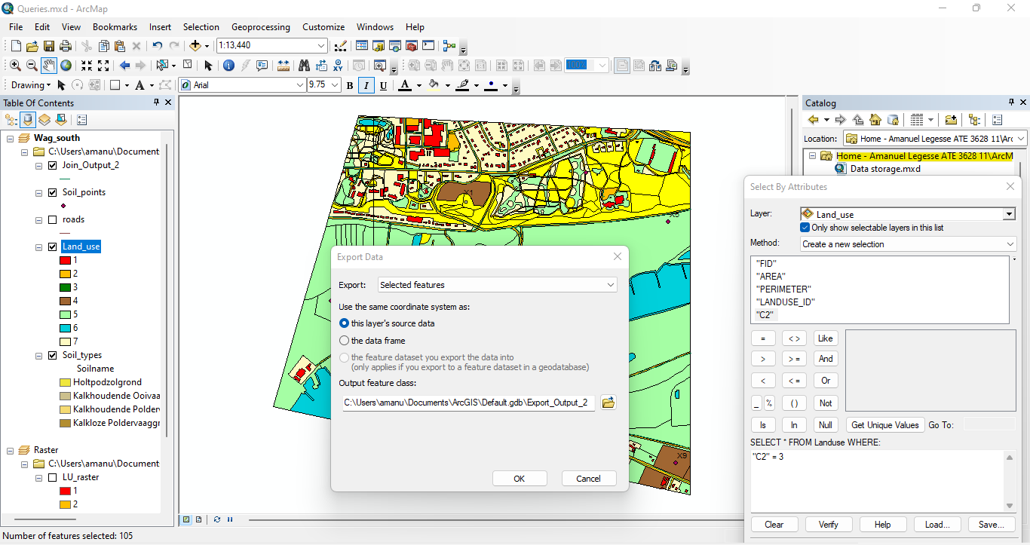

**Selecting and exporting raster cells using the ‘CON’ tool**

**A**: 15266 cells are selected.

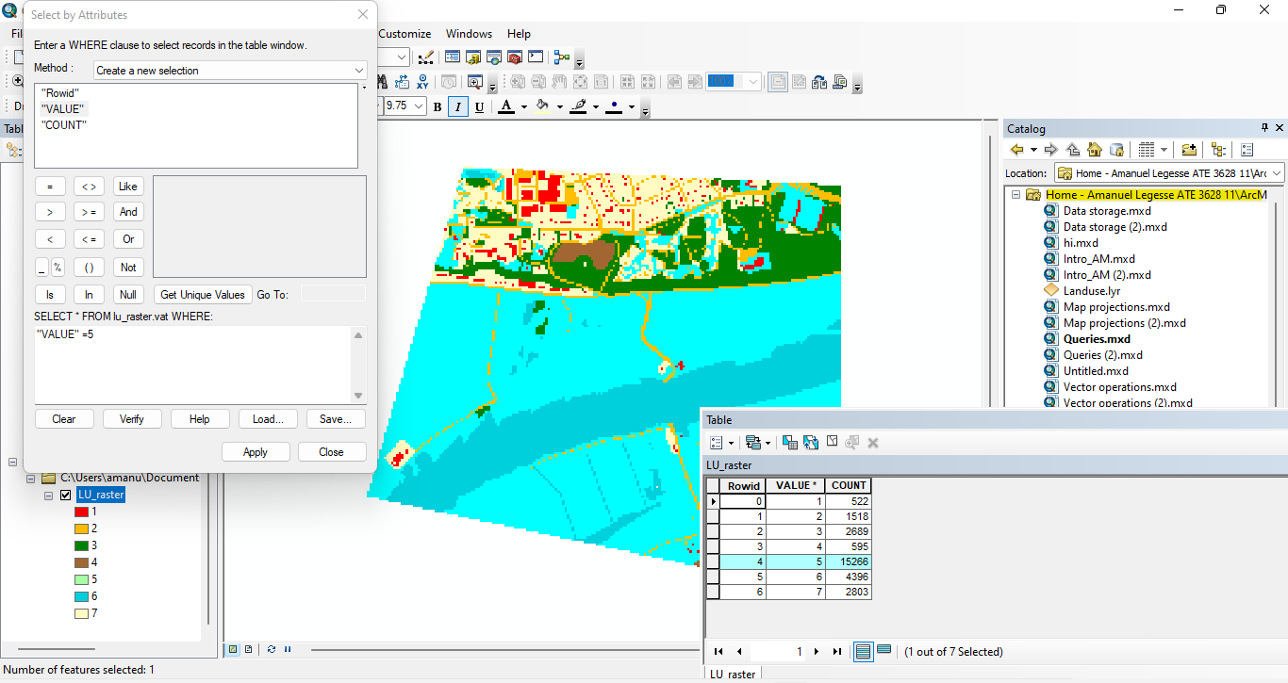

**B**: Classes with value 5 and 6 are selected.

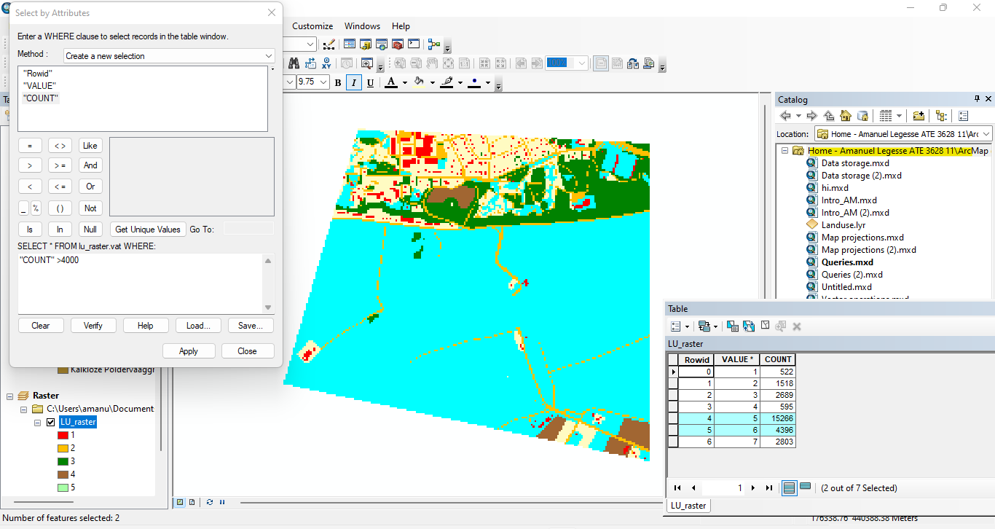

**C**: 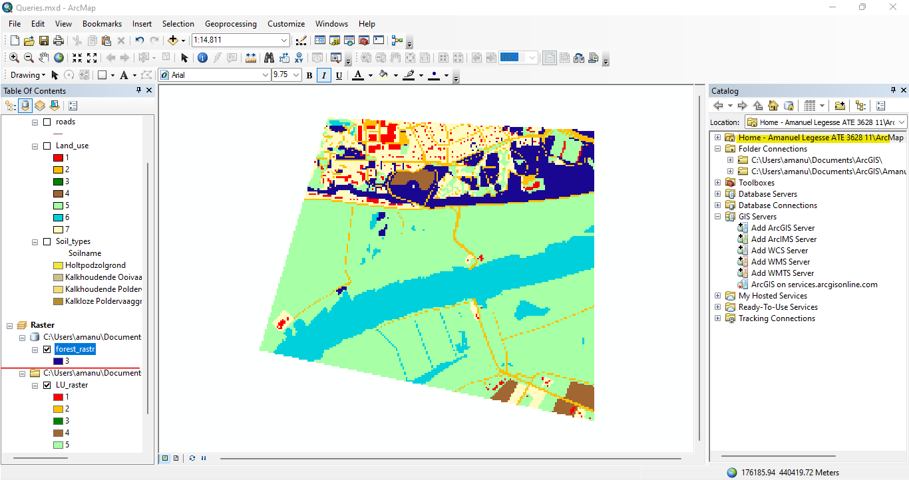

**D**:

